**Exercise – 1 : Creating Microservices for account and loan**

* Account Microservices

**Filename:** *AccountController.java*

package com.cognizant.account.controller;

import org.springframework.web.bind.annotation.*;

import java.util.Map;

@RestController

@RequestMapping("/accounts")

public class AccountController {

@GetMapping("/{number}")

public Map<String, Object> getAccountDetails(@PathVariable String number) {

return Map.of(

"number", number,

"type", "savings",

"balance", 234343

);

}

}

**Filename:** *AccountApplication.java*

package com.cognizant.account;

import org.springframework.boot.SpringApplication;  
import org.springframework.boot.autoconfigure.SpringBootApplication;  
  
@SpringBootApplication  
public class AccountApplication {  
  
 public static void main(String[] args) {  
 SpringApplication.*run*(AccountApplication.class, args);  
 }  
}

* Run AccountApplication.java
* Test in the browser
  + http://localhost:8081/loans/H00987987972342

**OUTPUT SCREENSHOTS :**

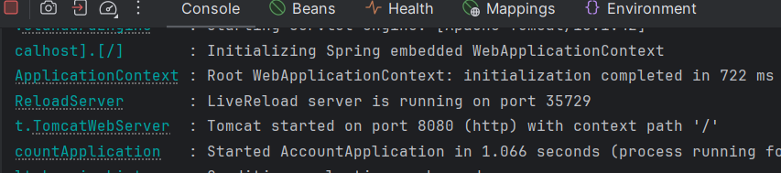

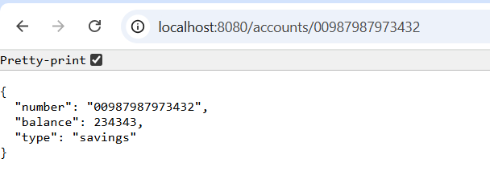

* Loan Microservices

**Filename:** *LoanController.java*

package com.cognizant.loan.controller;

import org.springframework.web.bind.annotation.*;

import java.util.Map;

@RestController

@RequestMapping("/loans")

public class LoanController {

@GetMapping("/{number}")

public Map<String, Object> getLoanDetails(@PathVariable String number) {

return Map.of(

"number", number,

"type", "car",

"loan", 400000,

"emi", 3258,

"tenure", 18

);

}

}

* Run LoanApplication.java
* Change the port to 8081 for avoiding conflicts
* Test in the browser
  + http://localhost:8081/loans/H00987987972342

**OUTPUT SCREENSHOTS :**

